High Value Poultry Partnerships

Intervention Training Manual

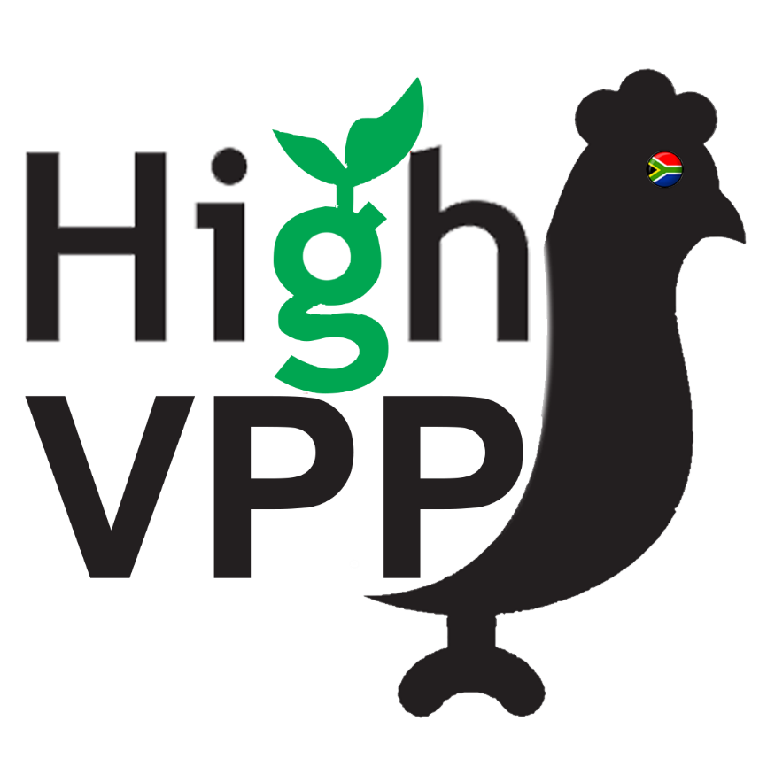

Contents
1. Purpose of Intervention 3
2. Focus on Profitability (Simple Gross Margins) 4
3. Treatment protocol 6
4. Control Protocol 7
5. Survey and Interview Protocol 8

Purpose of Intervention

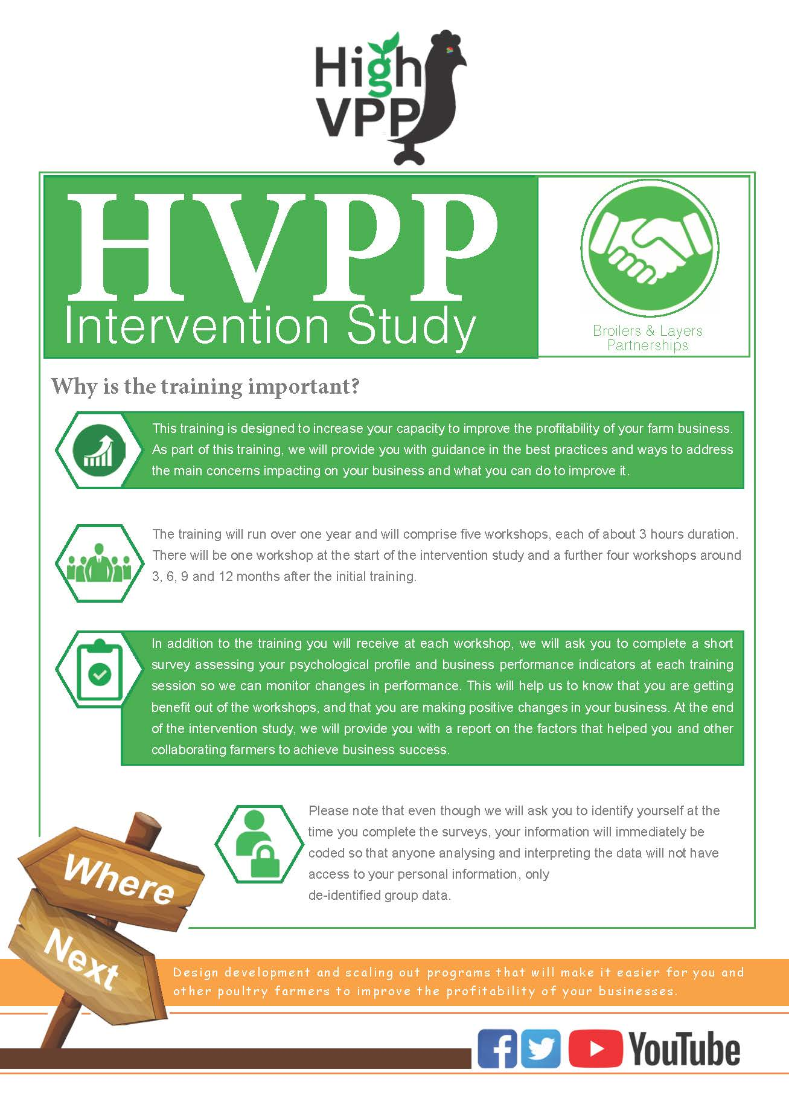

Focus on Profitability (Simple Gross Margins)

The focus of the 6-month intervention period will be for each farmer to improve the profitability of his/her farm business by at least 5% by June 2021 (assuming a revised start date of January 2021 and the possibility of meeting with the farmers every 2 months rather than the originally anticipated quarterly meetings).

Profit Focusing Tool

The profit focusing tool provides farmers with a simple approach to identifying the income and costs associated with their farming businesses). Very simply, the diagram shows that

Profit = Income – Costs
with income influenced by the price received for the product sold and the quantity of product sold

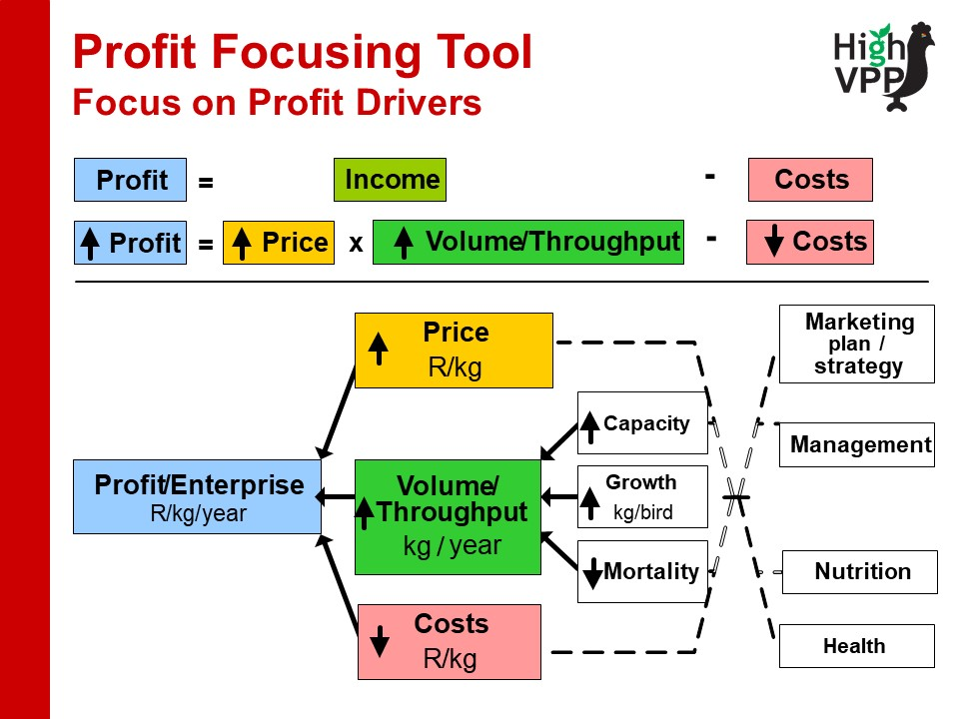

The aim of this tool is to identify ways of either increasing the price received or the volume sold or reducing the costs of undertaking the business. The following tables will be used to calculate gross margins for poultry farmers participating in the treatment groups.

BROILER PRODUCTION
Item | Quantity (Q) | Price per unit (P) | VALUE (RAND) = Q * P  (OR Indicate the TOTAL value here) | FOCUS Areas
INCOME
Total Broiler Sold (Live) |  |  | A
Total Broiler Sold (Packaged) |  |  | B
Total INCOME |  |  | C = A+B
COSTS
Labour costs (hired) |  |  | D
Value of stock (day old chicks) |  |  | E
Medication and vaccination cost |  |  | F
Purchased feed - cost |  |  | G
Electricity costs |  |  | H
Gas cost |  |  | I
Other costs |  |  | J
Total COSTS |  |  | K= D+E+F+G+H+I+J
GROSS MARGIN |  |  | GM = C - K

LAYER PRODUCTION
Item | Quantity (Q) | Price per unit (P) | VALUE (RAND) = Q * P  (OR Indicate the TOTAL value here) | Focus Areas
INCOME
Total number of eggs sold |  |  | A
Number of culled layers sold |  |  | B
Total INCOME |  |  | C = A+B
COSTS
Labour costs (hired) |  |  | D
Value of stock (day old chicks) |  |  | E
Medication and vaccination cost |  |  | F
Purchased feed - cost |  |  | G
Electricity costs |  |  | H
Gas cost |  |  | I
Other costs |  |  | J
Total COSTS |  |  | K= D+E+F+G+H+I+J
GROSS MARGIN |  |  | GM = C - K

During the training workshop, farmers will be encouraged to think of ways they could increase the profitability of their businesses, by either increasing their income or reducing their costs. In a previous project, farmers were encouraged to make all farm business decisions on the basis of whether or not the practice change they were thinking of implementing would improve their profit by at least 5% (and not to make the change if the profit improvement was less than 5% because those types of decisions were likely to be risky).

Treatment protocol

Summary of Protocol
- Video of role model – one video per intervention session, starting with basic level farmer(s), moving to intermediate level at second session and advanced level for third session.
- Facilitated group discussion on what works for the role model (and what does not work), what attributes does the farmer bring to the business that may be associated with their business success?
- CI&I outline (see below) with a pre-determined focus ‘to improve the profitability of each individual farm business by at least 5% by June 2021’
- Work through the CI&I process, using relevant tools for each of the Situation Analysis, Impact Analysis and Action Design steps (see below) to develop and document an individual action plan for each farmer for the following 2 months
- Verbal feedback from each farmer outlining their agreed action design and how they will implement in their business
- Completion of baseline survey form
- Agreement on date/time/venue for next meeting
- At next meeting(s), play and discuss second/third role model first video, review actions agreed at previous meeting, develop action plans and KPIs for next 2 months, complete interim survey form and agree on date/time/venue for next meeting

The six steps of the Continuous Improvement and Innovation (CI&I) process and the questions used to focus thinking and action to achieve CI&I

Control Protocol

Control Group

Each control farmer will need to complete the baseline and interim survey forms as part of their participation in the Poultry Performance Scheme (i.e. the only activity over and above their normal participation in the scheme will be completion of the shortened behaviour change survey on top of their normal farm business performance recording.

Survey and Interview Protocol

Summary of protocol
- Select the provinces. Consider the administrative and logistical considerations.
- List all districts per province.
- List all municipalities.
- Randomly allocate municipality into control and treatments groups.
- Collect the baseline information for all farmers within the selected municipality.
- Conduct the treatment.
- Collect monitoring and performance indicators.

Criteria for the selection of municipality
The following criteria will be used in selecting a municipality:
- Similar agro-ecological and physical characteristics.
- The poultry recording scheme is being implemented in these municipalities, where there are both layer and broiler farmers.
- Ensure that control municipalities are in good distance to avoid possible spillover and contamination.

Steps for selecting participants

- After randomly assigning municipalities into treatment and control groups, appropriate identification of samples is required.
- As the level of randomisation is at the municipal level, and given the relatively small size of the target cohort of poultry farmers in the scheme, the sample will include ALL farmers within the selected municipality.
- In order to balance the samples between treatment and control groups, consideration of the target size should be considered.

Provinces | Districts | Municipalities
Provinces | Districts | Control | Treatment
Limpopo | 5 Districts
Northwest | 4 Districts
Total sample required |  | At least 175 | At least 175

Interview and data collection protocol
- Collect the information using the registration schedule.
- Collect the behavioural information, using the BC survey instrument.
- Collect the business performance and related indicator

Following Cohen (1988), alpha = 0.05, power = 1- beta = 0.80; effect size = 0.30(small). The minimum sample size is 175. Because of the relatively small sample in Northwest, this is the total for both Limpopo and Northwest. If there will be no sufficient observations in the selected municipalities, we can change the total effect size of 0.4 (medium), thus having a minimum of sample size = 99 each for control and treatment.

